FR12 La publicité : Livre d’activités

Nom : _________________________
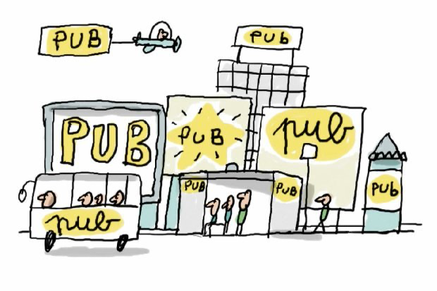
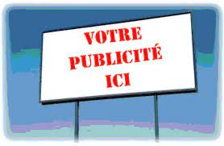 Les supports de la publicité! 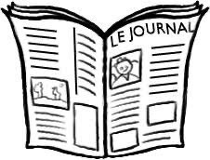

Support | Avantages | Désavantages
Les techniques de persuasion de la publicité 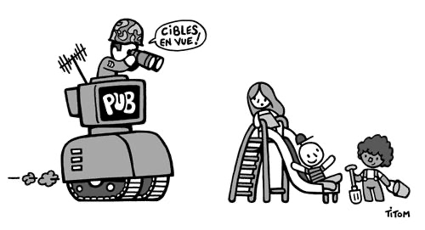

Techniques Exemple

- Mots à la mode ________________________________________________________
- Les gens ordinaires ________________________________________________________
- Faits et mots techniques ________________________________________________________
- Faire appel à des experts ________________________________________________________
- Symboles positifs ________________________________________________________
- Gens célèbres ________________________________________________________
- Effet boule de neige ________________________________________________________
- Fibre du snobisme ________________________________________________________
- La généralité ________________________________________________________
- La peur ________________________________________________________
- La comparaison ________________________________________________________
- La répétition ________________________________________________________
- Une chanson entrainante ________________________________________________________
- L’humour ________________________________________________________
- Une mascotte reconnaissable / identifiable _____________________________________________________
- La provocation des émotion fortes ________________________________________________________
- Faits intéressants ________________________________________________________
- ________________________________________________________
- ________________________________________________________
- ________________________________________________________
Les cibles / Les messages

Avertissement | Qui est ciblé? | Quel est le message?
Vocabulaire 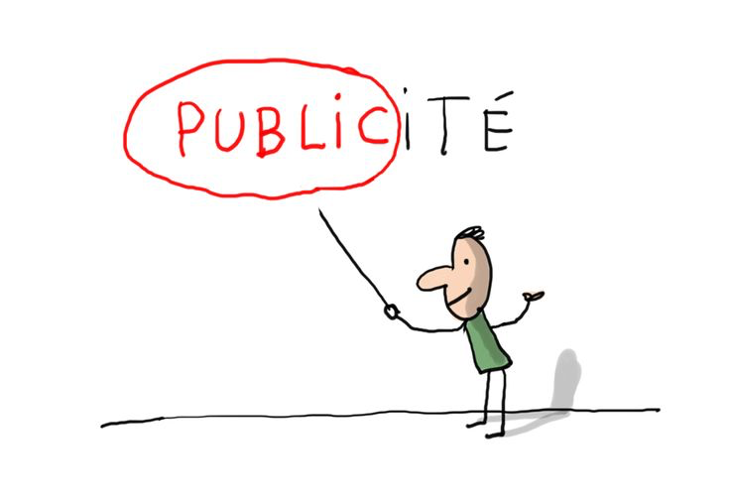
Mot en français Traduction
___________________________________ _______________________________________
___________________________________ _______________________________________
___________________________________ _______________________________________
___________________________________ _______________________________________
___________________________________ _______________________________________
___________________________________ _______________________________________
___________________________________ _______________________________________
___________________________________ _______________________________________
___________________________________ _______________________________________
___________________________________ _______________________________________
___________________________________ _______________________________________
___________________________________ _______________________________________
___________________________________ _______________________________________
___________________________________ _______________________________________
___________________________________ _______________________________________
___________________________________ _______________________________________
___________________________________ _______________________________________
___________________________________ _______________________________________
___________________________________ _______________________________________
La publicité et ses aspects

Produit / Service / Événement | Les techniques | Qui est ciblé? | Le message | Efficace?  Pourquoi / pas?
Fais ta pub !

Ton message :
Ton produit/service/événement :

Ton support / le contenu / l’histoire etc.

Tes techniques de persuasion:

Qui est ciblé?

